# CI/CD for Spring Boot microservices on Kubernetes

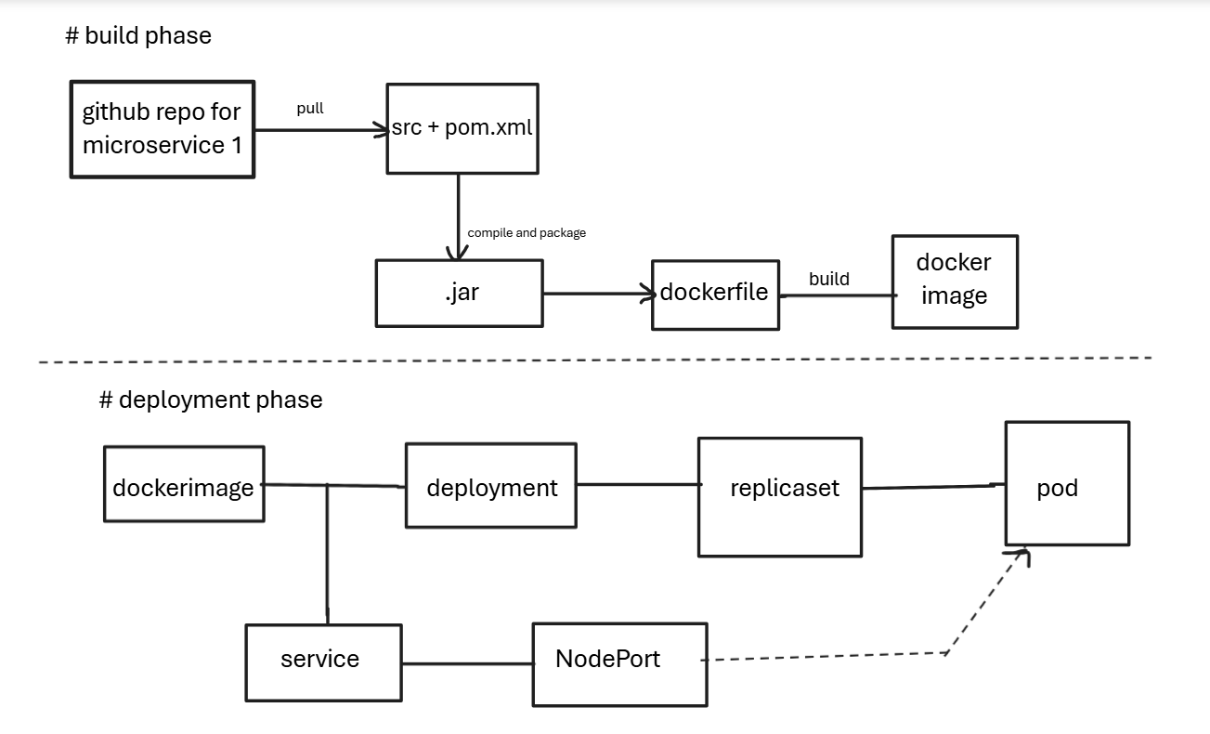

1. BUILD PHASE — CI (Continuous Integration)
Pull Source Code
- mvn clean package : This generates a .jar file - output of your Spring Boot application.
Build Docker Image
- Inside Dockerfile, you copy the JAR and define how the container will run.
- docker build -t shwetaraut815/jar:1.0 .
Test the image
Push Image to Docker Hub
- docker push shwetaraut815/jar:1.0

2. DEPLOYMENT PHASE — CD (Continuous Deployment)
Kubernetes Deployment Takes the Docker Image
Your YAML file (deployment.yaml) defines:
- which docker image to pull
- ReplicaSet
- labels
- container ports
Service.yaml
- Service type = NodePort
- Access it like http://<NodeIP>:<NodePort>
Workflow
GitHub → Jenkins → Maven → Docker → Docker Hub → Kubernetes Deployment → ReplicaSet → Pods → Service → NodePort → Browser

Your project is a CI/CD pipeline:
- Jenkins and Maven builds your Spring Boot JAR.
- Converts it into a Docker image.
- Pushes image to Docker Hub.
- Kubernetes pulls image automatically through deployment YAML.
- ReplicaSet maintains Pods.
- Service (NodePort) exposes your application.

# set up of kubeadm
Create 2 ec2 instances with t2.medium
###ON BOTH MASTER AND WORKER
[root@ip-172-31-37-30 ~]# history
1 clear
2 yum install docker -y && systemctl start docker
3 sudo setenforce 0
4 sudo sed -i 's/^SELINUX=enforcing$/SELINUX=permissive/' /etc/selinux/config
5 cat <<EOF | sudo tee /etc/yum.repos.d/kubernetes.repo
[kubernetes]
name=Kubernetes
baseurl=https://pkgs.k8s.io/core:/stable:/v1.34/rpm/
enabled=1
gpgcheck=1
gpgkey=https://pkgs.k8s.io/core:/stable:/v1.34/rpm/repodata/repomd.xml.key
exclude=kubelet kubeadm kubectl cri-tools kubernetes-cni
EOF

6 sudo yum install -y kubelet kubeadm kubectl --disableexcludes=kubernetes
7 history
Login to dockerhub

####On master only
8 kubeadm init
9 mkdir -p $HOME/.kube
10 sudo cp -i /etc/kubernetes/admin.conf $HOME/.kube/config
11 sudo chown $(id -u):$(id -g) $HOME/.kube/config
12 export KUBECONFIG=/etc/kubernetes/admin.conf
13 kubectl get nodes
Also create a calico.yaml file and run kubectl apply -f calico.yaml (this is 3rd party overlay network to establish communication between different hosts in k8s)
####On worker
7 kubeadm join 172.31.37.30:6443 --token jieisv.zjt3njx4lqt466c3 --discovery-token-ca-cert-hash sha256:87015f257d485b0f59e84837ff964a38bc0795402d98744d6d7c1e72c8821b8b

